**Future University**

**Business School**

**((Management Information Systems))**

**Historical & Educational Places (Website)**

**Class of 2020**

**Maged Ibrahim El-Sayed Eid ID:20163245**

**Table of contents:**

1. Abstract about the project.

2. Tables and Comparisons.

3. Introduction

4. Literature review

5. Analysis Phase (Use Case)

6. Analysis Phase (ERD)

7. Analysis Phase (DFD)

8…11 Design Phase (Activity diagrams for user)

12…14 Design Phase (Activity diagrams for admin)

15…17 Design Phase (Sequance diagrams for user)

18…19 Design Phase (Activity diagrams for user)

20. Implementation

21. Results and Discussion

22.Conclusion.

**Abstract**

**Problem:**

This website will solve the problem of finding new and unknown historical and educational places within Egypt, Cairo & Giza for anyone interesting in history or to gain knowledge, the website will solve the problem of making a plan for a day to make people not worry about where and when to go and help them share their new places with people like them whose share the same interest maybe on a specific historical areas in Egypt as ( Ancient Egypt monuments, ancient Greek or other historical preferences in Egypt), without any biases to specific places so the power at last in going to be to the visitors as they are going to be the ones who recommend new places and review places with their opinions where they find pros and cons of the places within the site and share their experience visiting these places with people.

**Scope:**

Focus on any one interesting in gaining knowledge specially (Students from all grades and majors) and for sure historical places are always bringing a great experience of learning new things. Many people like to visit historical places with their children. It is also helpful to improve educational skills. Such a visit is very helpful for your children to gain both fun and a good experience for them, they will see actually those things practically which they read about in their textbooks, historical visit also helps your children to explore new things and new knowledge. There is no time for family so traveling is one of the best ideas to spend more time with each other so to give them the right place to visit by my site is important. So mixing an educational trip while you choose historical places to visit is a good idea.

**Summary of the project & Outcomes:**

The website will include 5 pages (Sign-in, recommend place, choose plan, Search for place and view places), and will provide:

* Ease to use and understand UI
* Good number of places to choose from
* Places from wide range of historical eras as (Ancient Egypt, Ancient Greek and more UpToDate new educational places)
* Responsive for web browsers mobiles, tablets and other devises and this future is provided by wix.com which provide responsive templates for a lot of devices.
* Great experience to share your favorite places and thoughts with other people.
* Categorizing places to facilitate the search for users and make it more easily to whom the time are important.

Page 1

**Tables and Comparisons:**

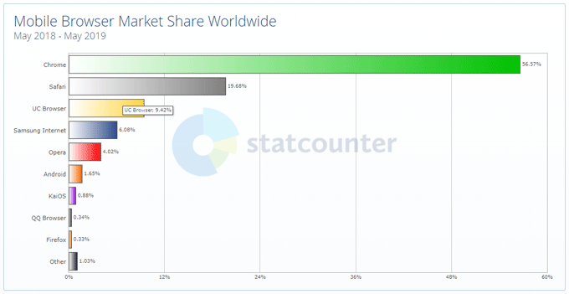

Comparison why choosing website over mobile app and develop the site ,try and testing it using chrome browser because chrome are the most popular browser in the world.

Source: <https://technumero.com/most-popular-web-browsers/>

Page 2

**Introduction Chapter:**

**Problem statement:**

Our problem in Egypt that we don’t have a one place to find good historical and educational places to go and most of blogs or any kind of examples are seem boring and dull to people when they read about just a big number of information that’s maybe not in their interest so the main purpose of the website is categorizing places to give people from different backgrounds and interests the right place to visit with real feedback from people like them so the user feel he is in the right place, and for sure provide good knowledge for people who like to stay home and it’s a must now to stay home during the current situation around the world so this is going to be the main feature in the website to give visitors photos, information and place to discuss with other people without leaving their home.

**Objectives**:

* Provide information and photos about many historical and educational places without the need of leaving home because staying safe at home during the current situation of corona virus is important so provide knowledge to visitors using only and device connected to internist is the main purpose of the website.
* Provide Places for different interests and backgrounds to gain visitors from all the world.
* Simple website without any complexation.
* Make the user experience sharing and communication with others easily by providing recommendation for new places from users.

**Scope of work:**

The complete of the website it is going to be on four phases:

**Phase 1:** The basic things on website as (Choose design & Template for the site, sign-in page, contact us (recommendation) and sample of chosen places).

**Phase 2:** Add the other features such as (Search, community guidelines add at least more 20 places)

**Phase 3:** Final touches on the website and get any more ideas to add to the website.

**Phase 4:** Publish it and get feedback from real users.

Page 3

**Literature review: Not sure to add it or not yet.**

Source: <http://citeseerx.ist.psu.edu/viewdoc/download?doi=10.1.1.196.7207&rep=rep1&type=pdf>

Page 4

**Analysis Chapter:**

**USE-CASE Diagram:**

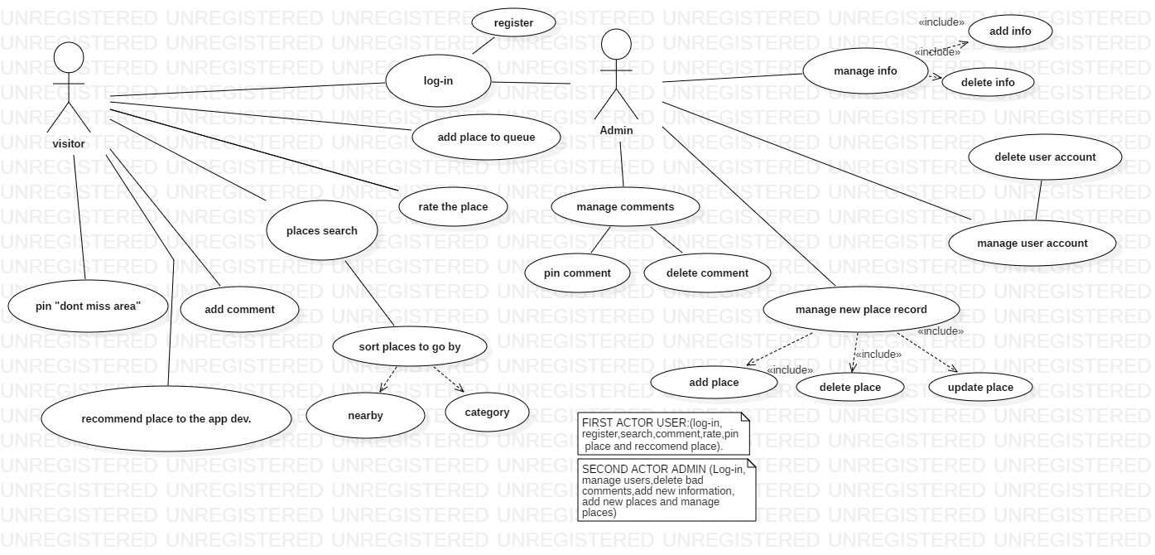

Page 5

**Entity Relation Diagram (ERD):**

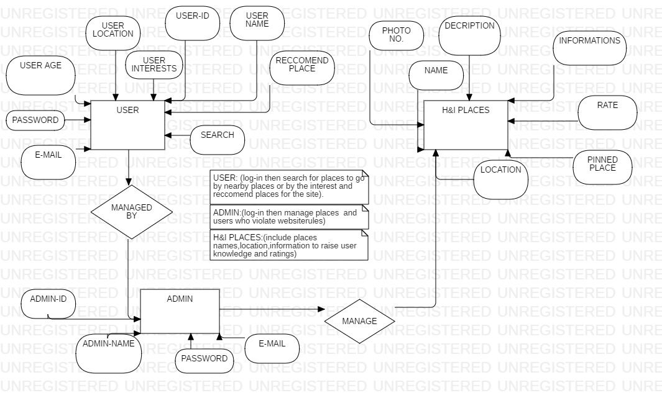

Page 6

**Data Flow Diagram (DFD):**

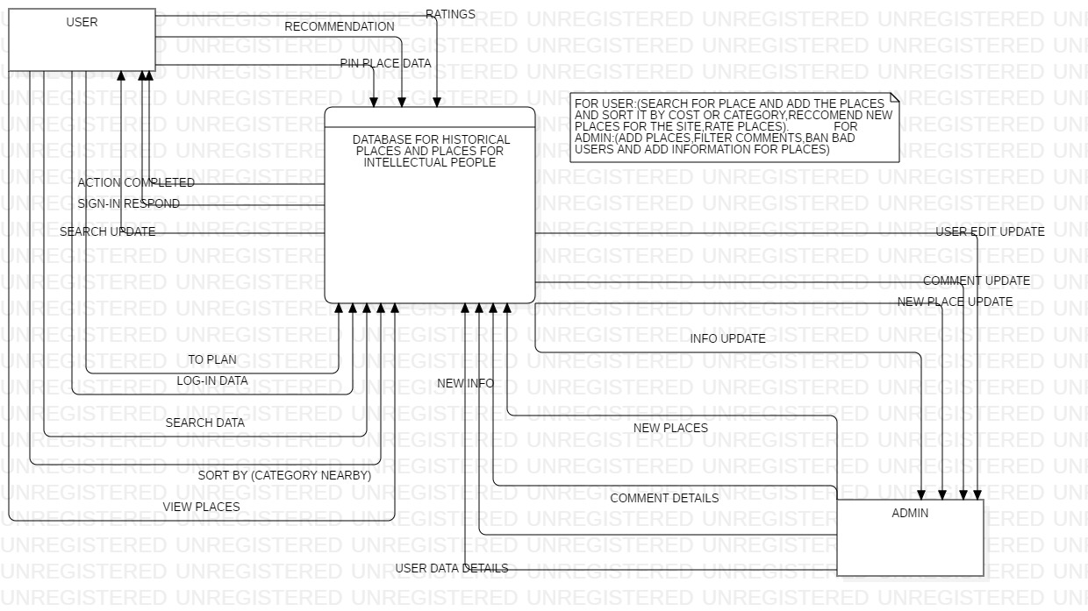

Page 7

**Design Chapter:**

**Activity Diagram for the (USER):**

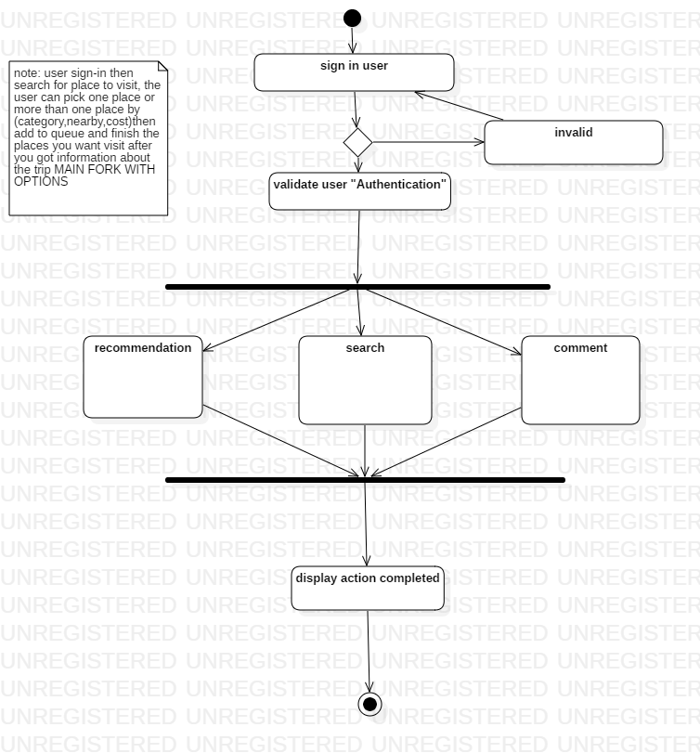

**User sign in to the website**

Page 8

**Activity Diagram for the (USER):**

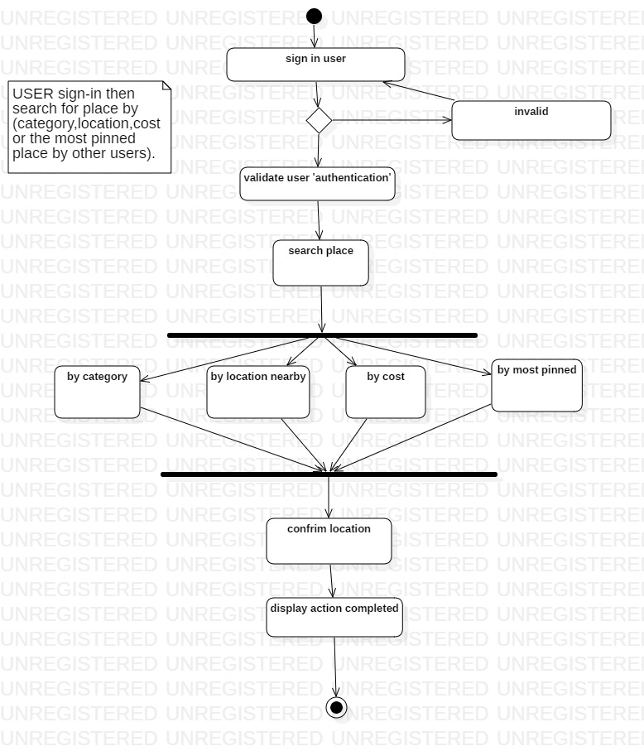

**User search for a place**

Page 9

**Activity Diagram for the (USER):**

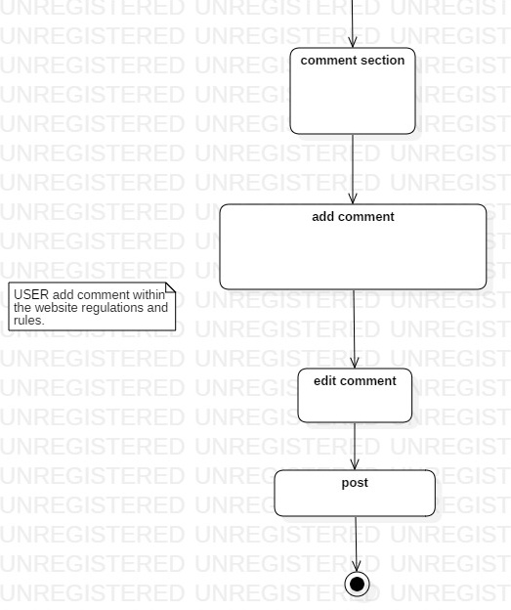

**User add comment to share his thoughts with other.**

Page 10

**Activity Diagram for the (USER):**

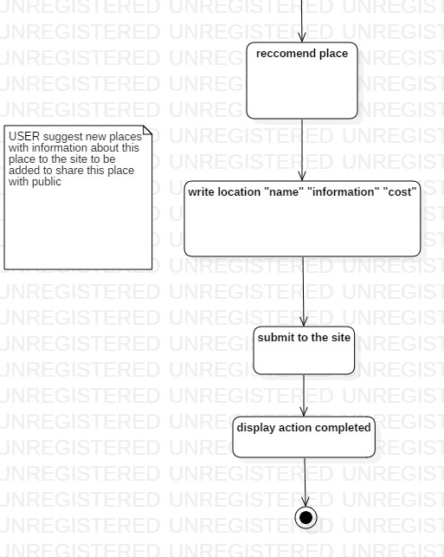

User share his most beloved places with other people to share opinions and thoughts about it.

Page 11

**Activity Diagram for the (ADMIN):**

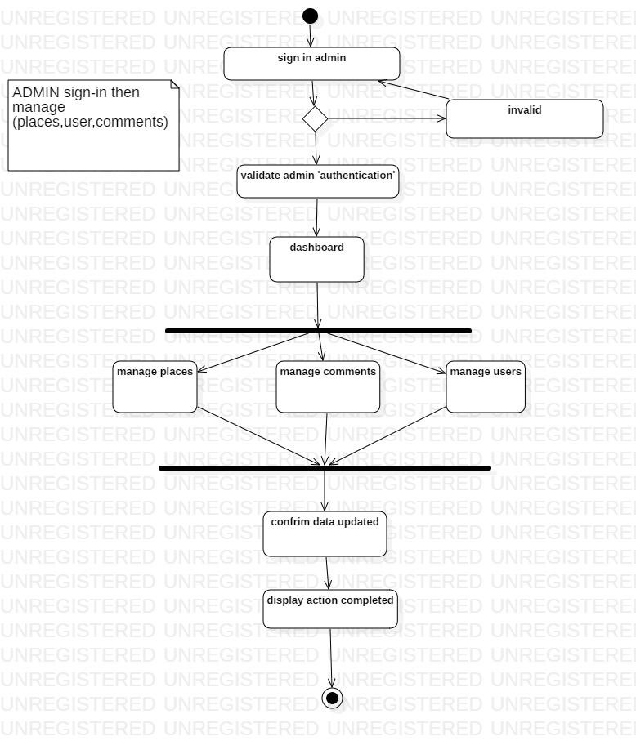

Admin sign-in main dashboard but its provided through Wix.com without any need for change

Page 12

**Activity Diagram for the (ADMIN):**

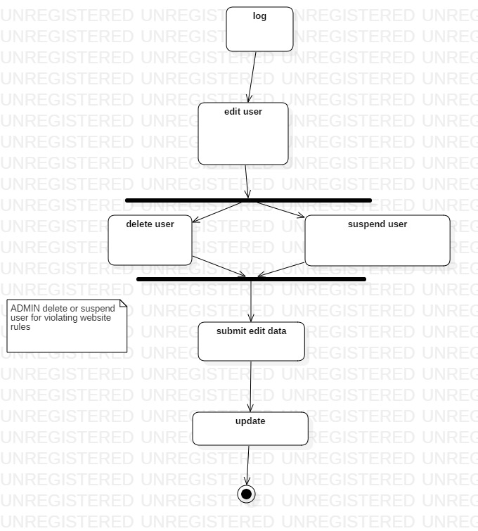

**Admin is the responsible to apply rules and community guidelines to provide a respectful and clean community within the website.**

Page 13

**Activity Diagram for the (ADMIN):**

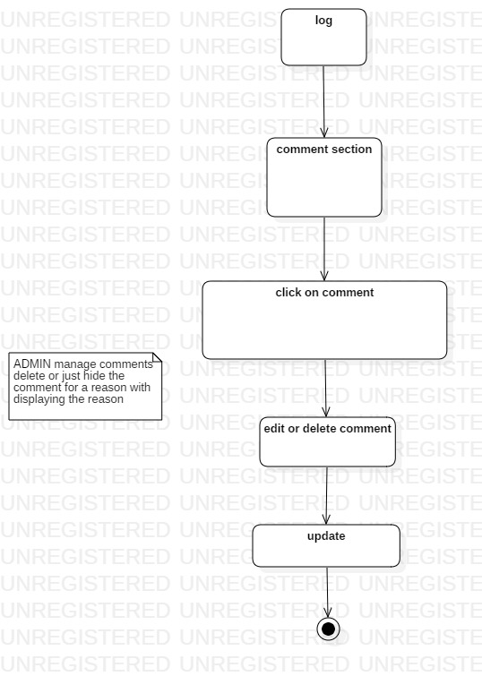

**Admin is the responsible to apply rules and community guidelines to provide a respectful and clean community within the website.**

Page 14

**Sequence Diagram (USER):**

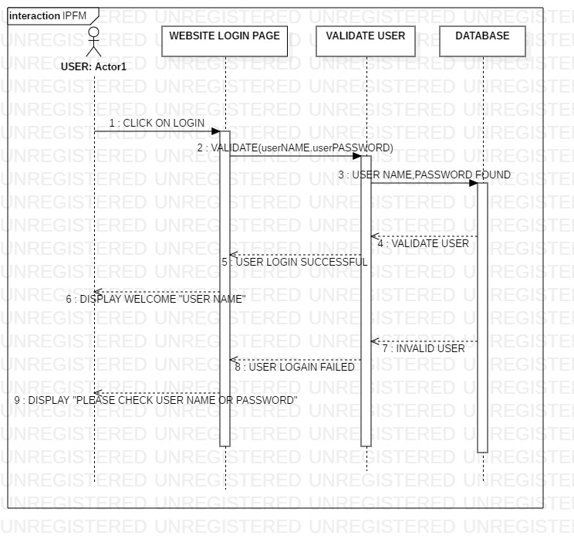

**User login**

Page 15

**Sequence Diagram (USER):**

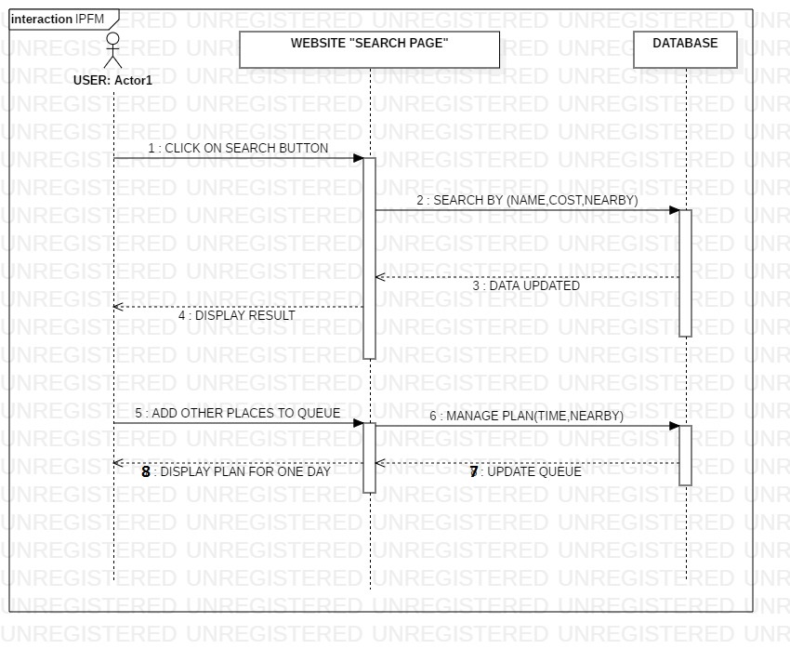

Page 16

**Sequence Diagram (USER):**

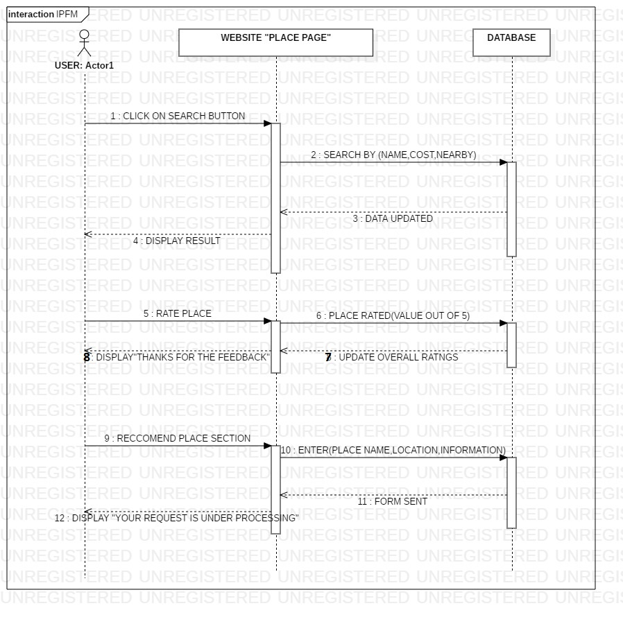

Page 17

**Sequence Diagram (ADMIN):**

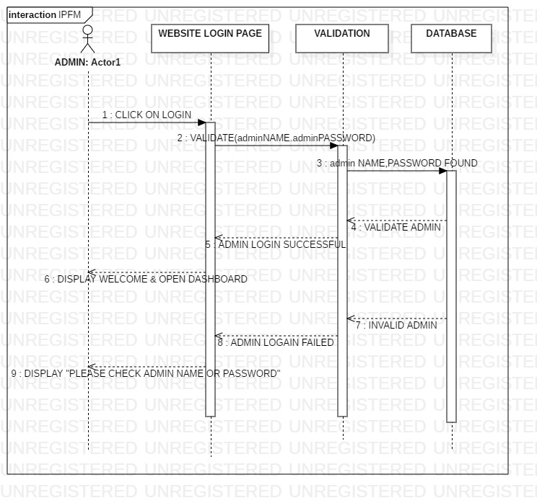

Page 18

**Sequence Diagram (ADMIN):**

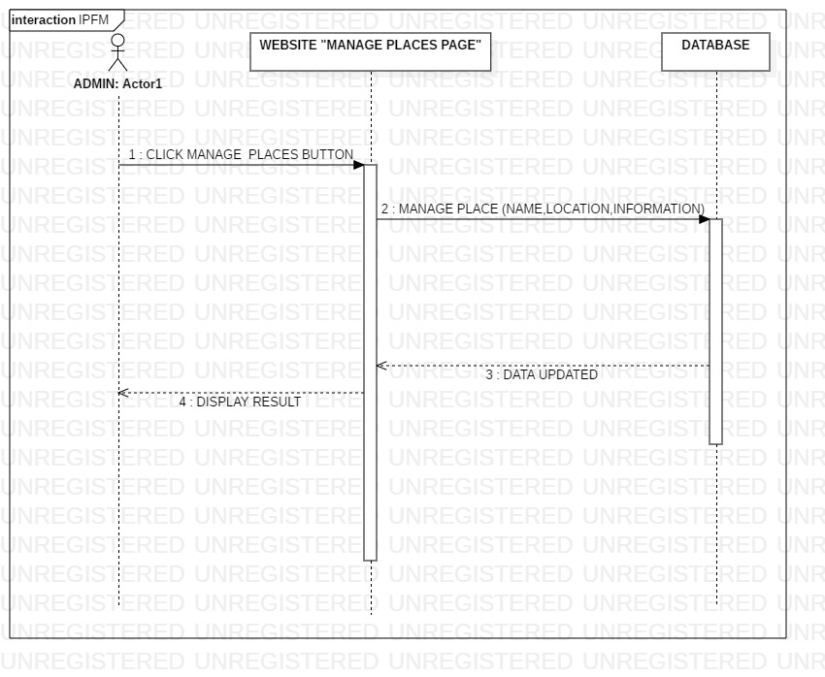

Page 19

**Implementation Phase:**

**Picture from the website to be uploaded soon.**

Page 20

**Results and Discussion:**

**At the End of the project to collect the results and feedback**

Page 21

**Conclusion:**

**When finalizing the website**

Page 22